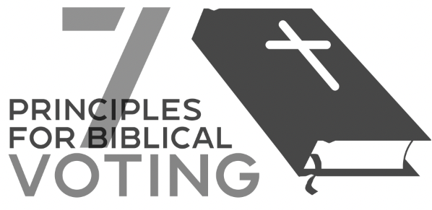

- Let God’s Word be your primary voting guide. Especially as you consider issues like the ballot proposals or consider policy priorities of different candidates, examine Scripture to see what God says about each issue. “Your word is a lamp to my feet and a light to my path” (Psalm 110:105).
- Pray before you vote. Lean on the Lord’s wisdom and guidance. “Trust in the LORD with all your heart, and do not lean on your own understanding. In all your ways acknowledge him…” (Prov. 3:5-6).
- Vote for candidates who upholds Biblical principles. Are his/her views on social and moral issues in line with Scripture? As Kingdom Ambassadors (2 ^{nd} Corinthians 5:20-21), we must not “give approval to those who practice” what God has declared to be morally evil (Rom. 1:32).
- Vote for candidate who will lead and advocate for justice. Is he/she is committed to a fair and righteous judicial system? “He has told you, O man, what is good; and what does the Lord require of you but to do justice, and to love kindness, and to walk humbly with your God?” (Micah 6:8).
- Vote for a candidate who has already demonstrated his/her ability to lead well. Inspect each candidate’s credentials and track record and see if the fruit of their labor is good or bad. “By their fruit you will recognize them.” (Matthew 7:16)
- Recognize that ultimately, it is God who raises up leaders to accomplish His good plan. “Let every person be subject to the governing authorities. For there is no authority except from God, and those that exist have been instituted by God” (Rom. 13:1). Ultimately, it is God—not people—who appoint leaders (Gen. 45:8). We still have an important duty to vote, because we are God’s instruments, and He works through us. However, we must remember to submit humbly to God’s sovereign will and pray for those who take office, no matter who they are. 1st Corinthians 1 tells us that God often works through the foolish and weak to show His strength and wisdom. Whatever the outcome of the election, one thing is certain: God will use this election for our sanctification. We prioritize peace and prosperity, but God is concerned about our piety and His eternal glory.
- ﻿Respect those with different opinions. Remember that every person you come in contact with is someone created in the image of God that Jesus died to save. Our job is to show the love of Christ at all times to all people, even when we disagree with them. “Be devoted to one another in love. Outdo yourselves in honoring one another.” (Romans 12:10)

